

Topic test 1
Name: __________________________________

Chapter 10: Properties of derivatives

• Time allowed: 45 minutes
• CAS calculators may be used.
• Part A: 6 multiple-choice questions (6 marks)
• Part B: 10 short answer questions (34 marks)
• Part C: 6 analysis questions (25 marks)
Part A
6 multiple-choice questions
1 mark each: 6 marks
Circle the correct answer.
1 When a function is increasing, the derivative is:
A decreasing
B negative
C positive
D 0
E increasing

[1 mark]
2 y = x³ + 2x² − 6x + 7. At x = −2, y is:
A increasing
B stationary
C negative
D decreasing
E 0

[1 mark]

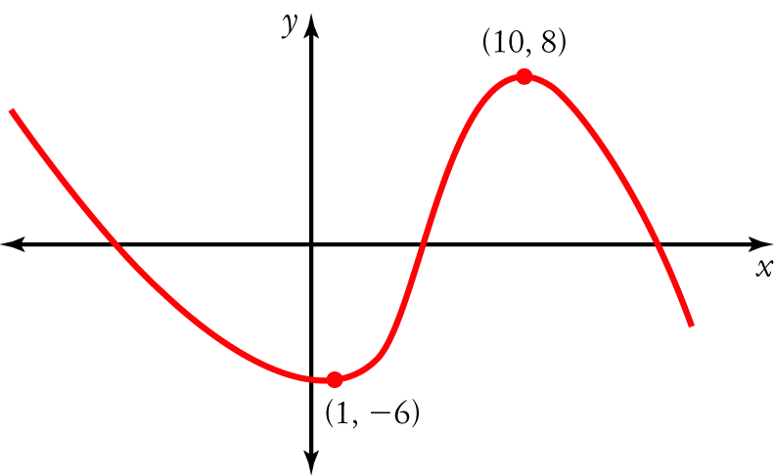
3 For the function shown on the right, the derivative is negative for:
A 1 < x < 10
B x > 10 only
C x < 1 and x > 10
D  −6 < x < 8
E x < 1 only

[1 mark]
4 If f(x) = 4x² − 3x + 7, then f ʹ(3) =
A 34
B 21
C 28
D 27
E 24

[1 mark]
5 The rate of change for f(x) = 5x² − 12x + 15 at x = 2 is:
A 32
B 9
C 15
D 23
E 8

[1 mark]
6 The antiderivative of 20x⁴ is:
A 4x⁵ + c
B 5x³ + c
C 20x⁵ + c
D 5x⁵ + c
E 80x³ + c

[1 mark]

Part B
10 short answer questions
34 marks
Show your working where appropriate.
1 State whether the function f(x) = 2x³ + 17x² − 12x + 8 is increasing, decreasing or stationary at:
a x = 1 ___________________________________________________________________
b x = −2 ___________________________________________________________________
c x = ___________________________________________________________________
[7 marks]
2 p(x) = 2x⁴ − 7x² + 8x − 9. Find:
a p ʹ(x) ___________________________________________________________________
b p ʹ(−3) ___________________________________________________________________
[2 marks]
3 If g(x) = −4x³ + 2x² + 5x − 3, calculate:
a 5g ʹ(x)

b g ʹ(x)

[3 marks]
4 If f ʹ(x) = 4x³ − 3x² − x and g ʹ(x) = −3x² + 4x + 5, calculate the derivative of 2f(x) − 7g(x).

[4 marks]
5 Find the derivatives of the following functions.
a p(x) = 7x⁵ − 8x³ + 5x + 11

b g(u) = 14 + 5u³ − 6u − 4u²

[2 marks]

6 Find the derivative of the function y = (2x³ + 5x)².

[2 marks]
7 Find the derivative of the function y = (3x − 2)³.

[2 marks]
8 f(x) = 4x² − 3x + 5.
a Find the average rate of change of from x = 1 to x = 5.

b Find the instantaneous rate of change at:
i x = 1 ___________________________________________________________________
ii x = 5 ___________________________________________________________________
iii x = 3 ___________________________________________________________________
c Compare the average rate of change and the instantaneous rates of change.

[8 marks]
9 Find two antiderivatives of f(x) = 8x³ − 4x + 7.

[2 marks]
10 Find y if 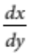 = 4 − 6x² − 2x⁵

[2 marks]
Part C
6 analysis questions
25 marks
Show your working where appropriate.
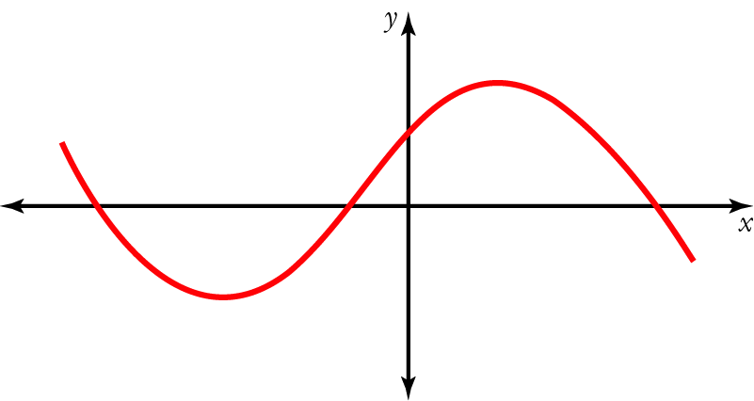
1 The graph of a function is shown on the right.
Use it to sketch a graph of the corresponding gradient function.

[4 marks]
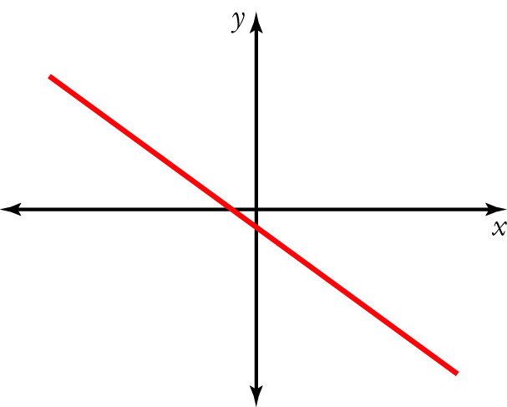
2 The graph of a gradient function is shown on the right.
Use it to sketch a graph of the corresponding function.

[4 marks]
3 f(x) = 2x² + x − 4.
a Find the gradient of the tangent at x = 1.

b Find the equation of the tangent at x = 1.

[7 marks]

4 The current I in amperes in a particular electrical circuit is given by I = 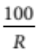, where R is the resistance in
ohms (Ω). Find the rate of change of I with respect to R when the resistance is 20 Ω.

[3 marks]
5 The volume of water flowing through a pipe is given by V = t² + 3t, where V is the volume in litres and t is the time in minutes. Find the rate of water flow after 5 minutes.

[3 marks]
6 For the graph of a function, y = f(x), the rate of change of y values with respect to its x values is given by
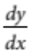 = 3x² − 2x + 1. Given that the graph passes through the point (−1, 3), find the equation of the function.

[4 marks]
Total marks: 65

Answers
Part A [1 mark each]
1 A function is increasing when the derivative is positive.
∴ C [1 mark]
2 y ʹ = 3x² + 4x − 6, so when x = −2, y ʹ = −2
∴ y is decreasing.
∴ D [1 mark]
3 The derivative is the same as the gradient (slope). The function has a negative gradient when x < 1 and x > 10.
∴ C [1 mark]
4 f ʹ(x) = 8x − 3 so f ʹ(3) = 21.
∴ B [1 mark]
5` The derivative gives the rate of change. f ʹ(x) = 10x − 12 so f ʹ(2) = 8.
∴ E [1 mark]
6 f(x) = 20x⁴, so F(x) = 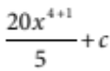 = 4x⁵ + c.
∴ A [1 mark]

Part B
1 f(x) = 2x³ + 17x² − 12x + 8
f ʹ(x) = 6x² + 34x − 12 [1 mark]
a f ʹ(1) = 6 × 1² + 34 × 1 − 12 = 28 [1 mark]
f ʹ(1) > 0 ∴ f(x) is increasing. [1 mark]
b f ʹ(−2) = 6 × (−2)² + 34 × (−2) − 12 = −56 [1 mark]
f ʹ(−2) < 0
∴ f(x) is decreasing. [1 mark]
c f ʹ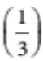 = 6 × 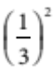+ 34 × − 12 = 0 [1 mark]
f ʹ = 0
∴ f(x) is stationary. [1 mark]
[7 marks]
2 a p ʹ(x) = 8x³ − 14x + 8 [1 mark]
b p ʹ(−3) = 8 × (−3)³ − 14 × (−3) + 8 = −166 [1 mark]
[2 marks]

3 g ʹ(x) = −12x² + 4x + 5 [1 mark]
a 5g ʹ(x) = 5(−12x² + 4x + 5) = −60x² + 20x + 25 [1 mark]
b g ʹ(x) = (−12x² + 4x + 5) = −8x² + 2x + 3 [1 mark]
[3 marks]
4 D[2f (x) − 7g(x)] = 2f ʹ(x) − 7g ʹ(x) [1 mark]
= 2(4x³ − 3x² − x) − 7(−3x² + 4x + 5) [1 mark]
= 8x³ − 6x² − 2x + 21x² − 28x − 35 [1 mark]
= 8x³ + 15x² − 30x − 35 [1 mark]
[4 marks]
5 a p ʹ(x) = 35x⁴ − 24x² + 5 [1 mark]
b g ʹ(u) = 15u² − 6 − 8u [1 mark]
[2 marks]
6 y = (2x³ + 5x)² = 4x⁶ + 20x⁴ + 25x² [1 mark]
y ʹ = 24x⁵ + 80x³ + 50x [1 mark]
[2 marks]
7 y = (3x − 2)³ = 27x³ − 54x² + 36x − 8 [1 mark]
y ʹ = 81x² − 108x + 36 [1 mark]
[2 marks]
8 a f(1) = 4 × 1² − 3 × 1 + 5 = 6 [1 mark]
f(5) = 4 × 5² − 3 × 5 + 5 = 90 [1 mark]
Average rate of change = 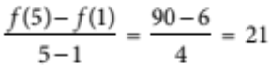 [1 mark]
b Instantaneous rate of change = f ʹ(x) = 8x − 3 [1 mark]
i f ʹ(1) = 8 × 1 − 3 = 5 [1 mark]
ii f ʹ(5) = 8 × 5 − 3 = 37 [1 mark]
iii f ʹ(3) = 8 × 3 − 3 = 21 [1 mark]
c The average rates of change for the values checked is the average of the instantaneous rates for the endpoints of the intervals for the average rates of change. [1 mark]
[8 marks]
9 F(x) = 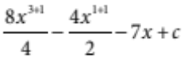 = 2x⁴ − 2x² − 7x + c [1 mark]
Two possible antiderivatives are 2x⁴ − 2x² − 7x + 5 and 2x⁴ − 2x² − 7x − 6. [1 mark]
[2 marks]
10 y = 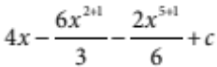 = 4x − 2x³ − x⁶ + c [1 mark + 1 mark for the + c]
[2 marks]
Part C
1 The key features of the graph of the gradient function, g(x), are found by examining the graph of the function, f(x). These are:
• f(x) is stationary on either side of the y-axis. This means that g(x) will be zero at these x values. [1 mark for showing this feature on the graph]
• f(x) has a positive slope between the stationary points. This means that g(x) will be positive between these
x values. [1 mark for showing this feature on the graph]
• Looking from left to right, f(x) has a negative slope on the left of the first stationary point and on the right of the second stationary point. This means that g(x) will be negative at these x values. [1 mark for showing this feature on the graph]
• The steepness of the graph of g(x) is determined by the steepness of the tangent to the graph of f(x). [1 mark for showing this feature on the graph]
[4 marks]
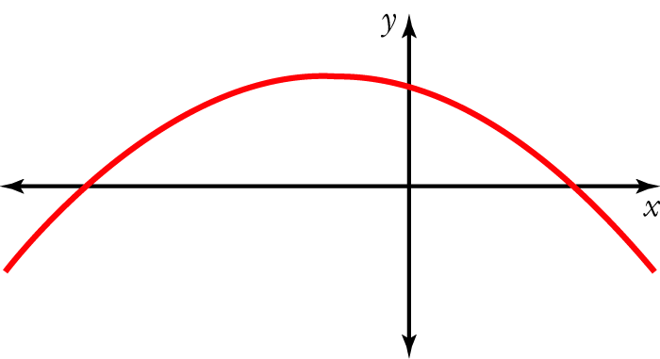
2 The key features of the graph for the function, f(x), are found by examining the graph of the gradient function, g(x). These are:
• g(x) is zero just to the left of the y-axis. This means that f(x) will be stationary at this x value. [1 mark for showing this feature on the graph]
• g(x) is positive to the left of the intercept with the x-axis. This means that f(x) will have a positive gradient for these x values. [1 mark for showing this feature on the graph]
• g(x) is negative to the right of the intercept with the x-axis. This means that f(x) will have a negative gradient for these x values. [1 mark for showing this feature on the graph]
• The values of g(x) indicate the steepness of the tangent to the graph of f(x) − higher values of g(x) indicate that the graph of f(x) will be steeper than at lower values of g(x). [1 mark for showing this feature on the graph]
[4 marks]
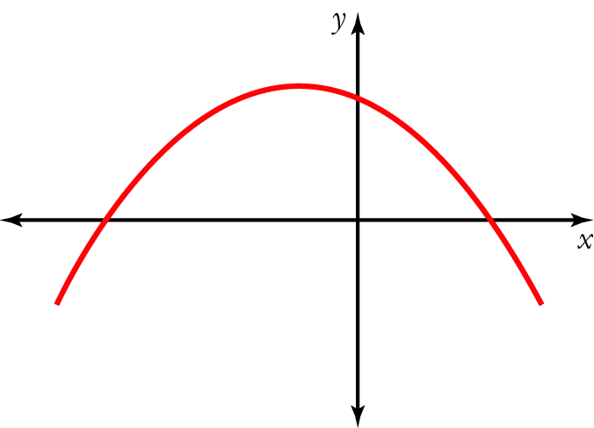

3 a f ʹ(x) = 4x + 1 [1 mark]
f ʹ(1) = 4 × 1 + 1 = 5 [1 mark]
Gradient of tangent to f(x) = 2x² + x − 4 at x = 1 is 5. [1 mark]

b f(1) = 2 × 1² + 1 − 4 = −1 [1 mark]
Tangent passes through (1, −1) and has a gradient of 5.
Equation of tangent: y − y₁ = m(x − x₁) [1 mark]
[y − (−1)] = 5(x − 1) [1 mark]
y = 5x − 6 [1 mark]
[7 marks]
4 The rate of change of I with respect to R =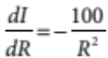 [1 mark]
When R = 20 Ω,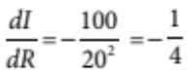 [1 mark]
When R = 20 Ω, the current is decreasing at the rate of amperes per ohm. [1 mark]
[3 marks]
5 Rate of water flow: V ʹ = 2t + 3 [1 mark]
Flow rate after 5 minutes = 2 × 5 + 3 = 13 [1 mark]
After 5 minutes the water is flowing at 13 L/min. [1 mark]
[3 marks]
6 f ʹ(x) = 3x² − 2x + 1
f(x) = 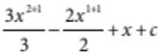 = x³ − x² + x + c [1 mark]
f(−1) = 3 = x³ − x² + x + c [1 mark]
3 = (−1)³ − (−1)² + −1 + c
3 = −1 − 1 − 1 + c
c = 6 [1 mark]
y = x³ − x² + x + 6 [1 mark]
[4 marks]

